
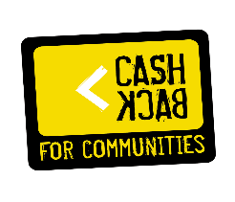

YoMo Young Movers
JOB DESCRIPTION: Youth Work Lead - Full Time (35 hours)

Job Title: Youth Work Lead
Location: The Base, Glenavon North Maryhill & Easterhouse
Responsible to: Project Manager.
Start date: As soon as possible.
Hours of work:
Full time post 35 hours per week, with hours worked varying over days, nights and weekend duties as required.
Part time post 25 hours per week, with hours worked varying over days, nights and weekend duties as required.
Salary: £28,000 to £30,000 per annum depending on experience.
Main purpose and duties:
We are looking for 2 Youth Work Leads to deliver youth sessions, clubs and activities for our young people and families within YoMo services across Glasgow the delivery will be varied and will always be driven by the needs of young people and the community.
There will also be the remit of devising and implementing new projects and clubs as guided by funding requirements and service user’s needs. These will include building and creating programs that provide accreditation through youth and SQA awards that build skills for young people’s future employment.
You will work in partnership with local organisations, social work and schools and build up strong positive community links. You will work to enhance the lives of young people by ensuring activities are provided to develop their mental, emotional, physical and social well-being needs.
You will have the responsibility of helping with fundraising drives and initiatives.
You will also be committed to ongoing personal development and undertake training or other professional development activities as required.
All other reasonable duties will be required to be undertaken as and when required and agreed with the Project Manager.
Applications: Please send your CV and supporting covering letter linking your experience to the person specifications to info@yomo-online.co.uk.
Closing date for application will be the 23rd March at noon if your application processes to interview these will be held on the 31st March 2026.

